**AE 771 FINAL EXAM  
Prof. Ray Taghavi**

Taken by: Henry Hunt

Submitted by: May 14th

**PART A ANSWERS**

|  |  |  |  |
| --- | --- | --- | --- |
| **Variable** | **Value Ideal** | **Value Actual** | **Unit** |
| Exhaust Velocity | 9170 | 9170 | Ft/s |
| Specific Impulse | 285 | 279 | Sec |
| Ideal Thrust Coefficient | 1.58 | 1.53 | Unitless |
| Throat Radius Ideal | 17.41 | 17.67 | In |
| Area Radio | 8.21 | 8.21 | Unitless |
| Nozzle Exit Area | 7817.7 | 8059.5 | In2 |
| Mach Number at Nozzle Exit | 3.2 | 3.2 | Unitless |
| Total Propellant Weight Flowrate | 5263 | 5376 | Lbf/s |
| Total Propellant Volume Flowrate | 80.1 | 81.8 | Ft2/s |
| Oxidizer Weight Flowrate | 3638.73 | 3716.74 | Lbf/s |
| Fuel Weight Flowrate | 1624.43 | 1659.26 | Lbf/s |
| Oxidizer Volume Flowrate | 52.18 | 52.27 | Ft3/s |
| Fuel Volume Flowrate | 28.91 | 29.53 | Ft3/s |
| Oxidizer Weight [3 min] | 654970 | 669013 | Lbf |
| Fuel Weight [3 min] | 292397 | 298667 | Lbf |
| Oxidizer Volume [3 min] | 9212 | 9409.5 | Ft3 |
| Fuel Volume [3 min] | 5204.2 | 5315.8 | Ft3 |

|  |  |  |
| --- | --- | --- |
| **Variable** | **Value** | **Unit** |
| Rao Nozzle Inflection Angle | 24 | Deg |
| Nozzle Exit Angle | 11 | Deg |
| Length of Combustion Chamber | 50.89 | In |
| Diameter of Combustion Chamber | 70.69 | In |
| Axial First Mode Frequency | 66.249 | Hz |
| Tangential First Mode Frequency | 20.252 | Hz |
| Radial First Mode Frequency | 63.622 | Hz |

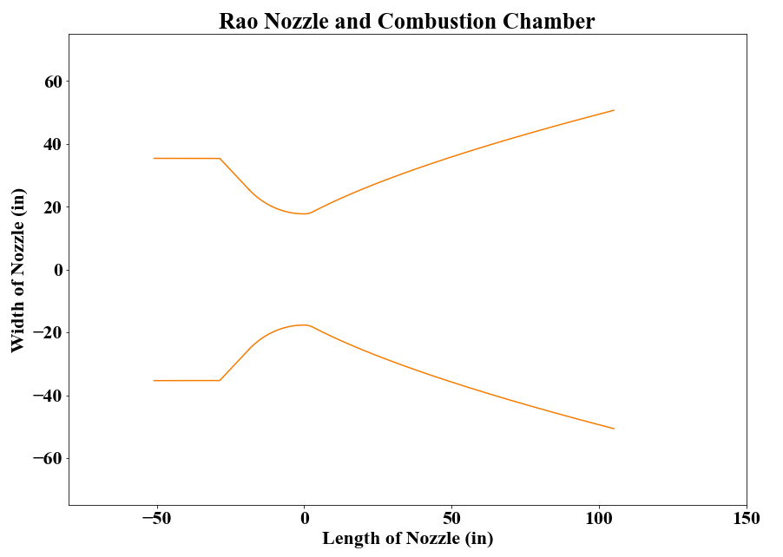

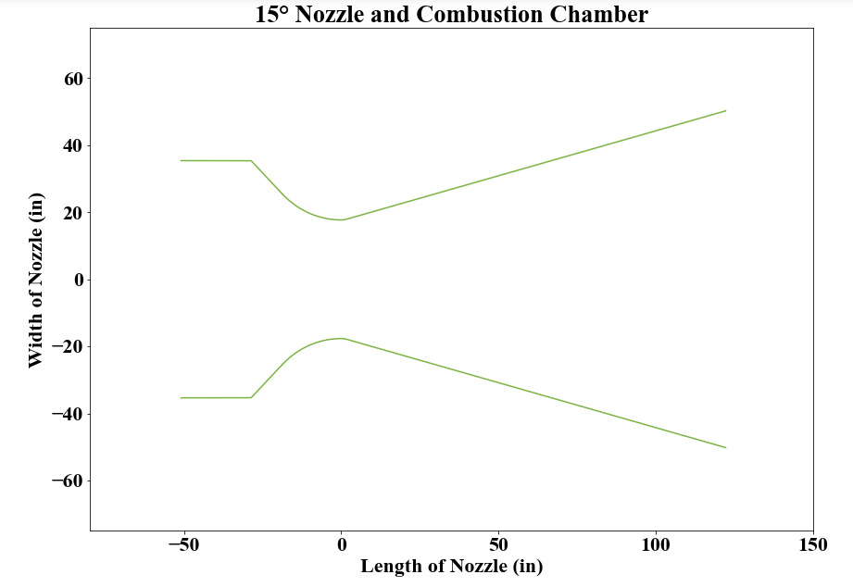

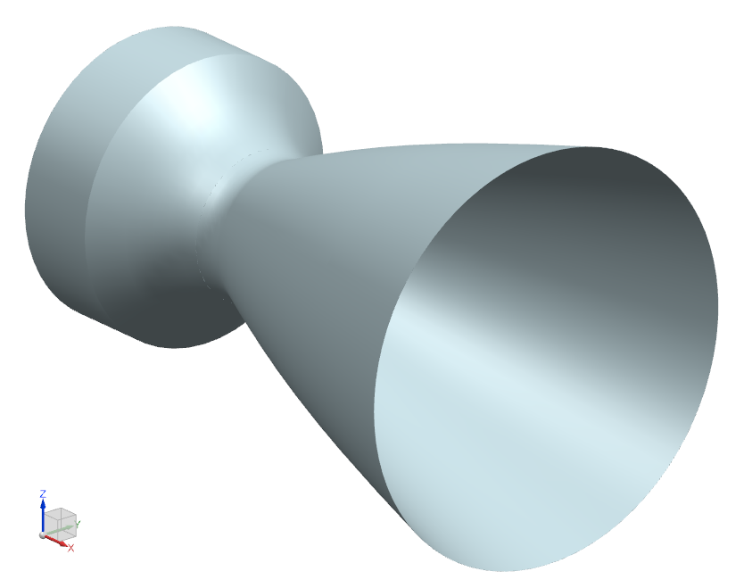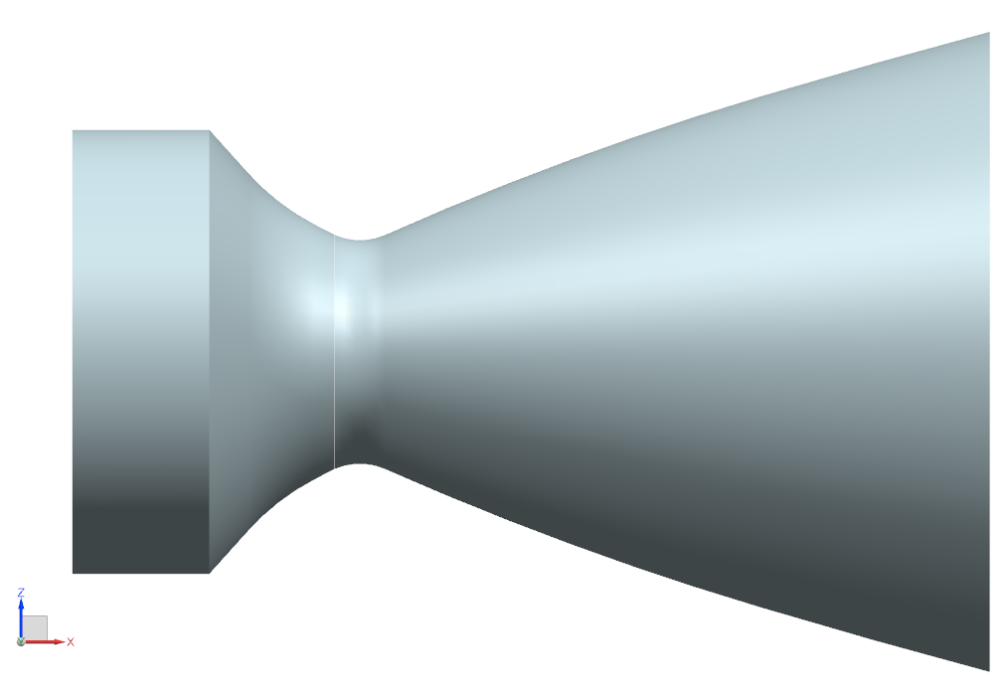

**F1 Rao Engine**

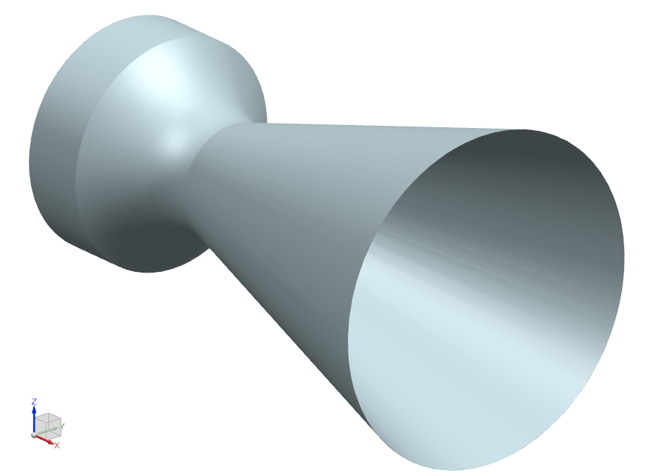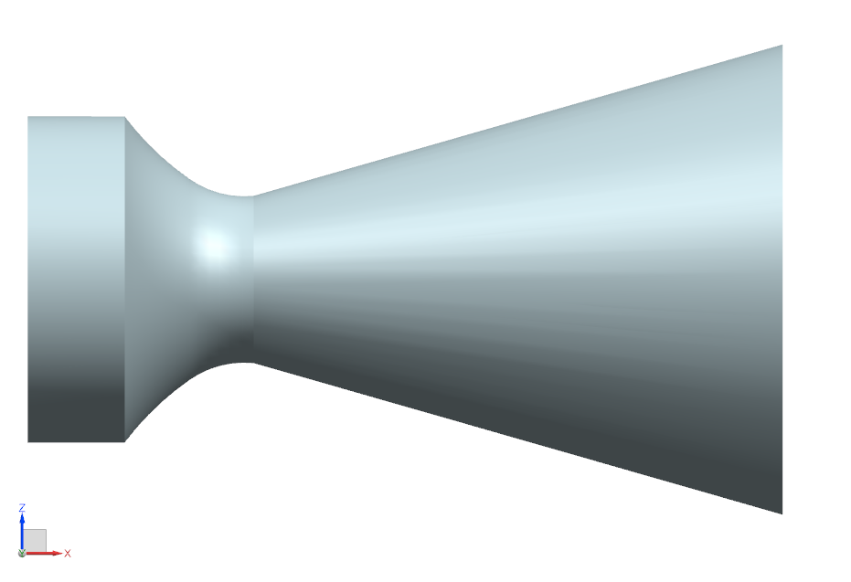

**F1 Cone Engine**

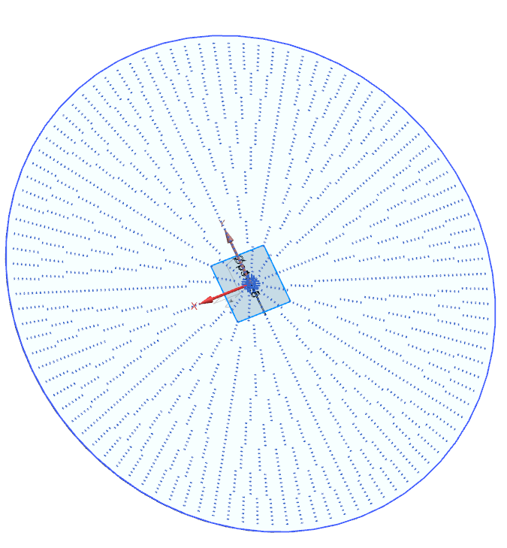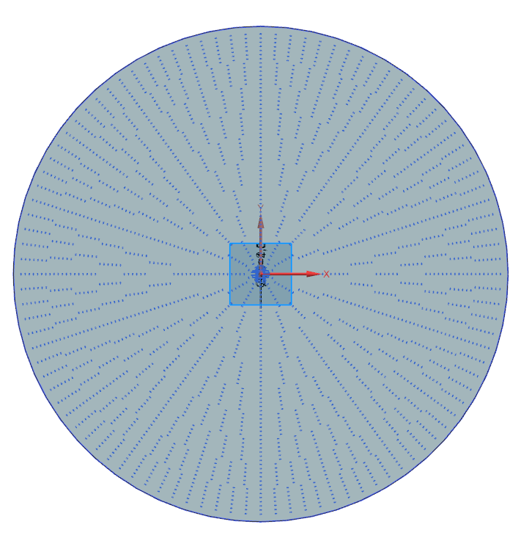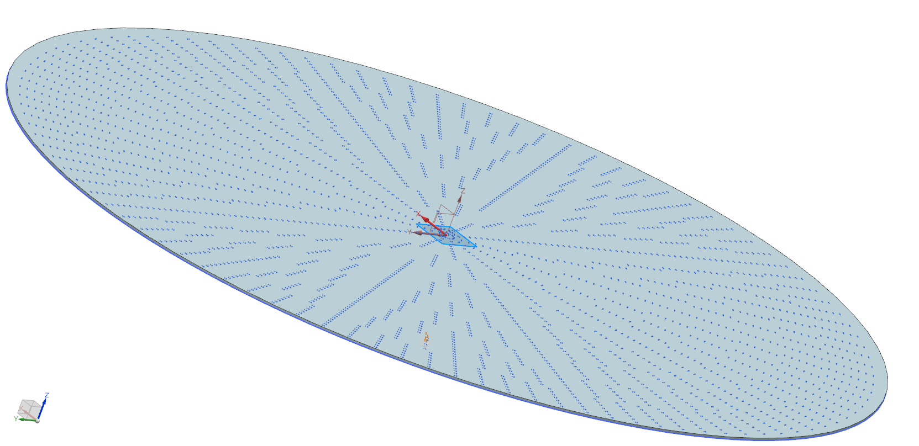

**PART B ANSWERS**

|  |  |  |
| --- | --- | --- |
| **Variable** | **Value** | **Unit** |
| Structural Mass Fraction | 0.107 | ~ |
| Payload Mass Fraction | 0.011 | ~ |
| Single Stage Velocity Increment | 19017 | Ft/s |
| Orbital Velocity at 100 miles? | 25607 ft/s, NO | bool |
| Escape Velocity at 100 miles? | 36214 ft/s, NO | bool |
| 2 Stage Velocity Increment | 38035 | Ft/s |
| 3 Stage Velocity Increment | 57053 | Ft/s |

**PART C ANSWERS**

|  |  |  |
| --- | --- | --- |
| **Variable** | **Value** | **Unit** |
| Liquid Film Coefficient | 7278.294 | W/m2-K |
| Steady State Heat Flux | 3199500 | Watts/m2 |
| Temperature of Wall on Coolant Side | 549.595 | K |
| Thickness of Wall for 900k | 1.314 | mm |

**PART D ANSWERS**

**Question 1**

1. What is the total number and approximate thrust of the following engines on the Space Shuttle?
   1. Space Shuttle Main Engines: 3, at 1.86 MN or 2.28 MN for vacuum
   2. Orbital Maneuvering Engines: 2, at 26.7 kN
   3. Reaction Control Engines (main & Vernier thrusters): 26, at 870lb main and 4, at 24 lb for Vernier.
   4. Solid Rocket Boosters: 2, at 12 MN
2. Which one of the above space shuttle rocket engines use the exact same propellant?
   1. The **Reaction Control System Engines** and the **Orbital Maneuvering Engines** use the same propellant
3. What is the total operating time during each launch for the SRBs and SSMEs?
   1. SRB: 124 seconds
   2. SSME: 480

**Question 2**

1. What is the difference between “Hybrid Rockets” and “Inverse Hybrid Rockets”?
   1. Hybrid rockets have a liquid oxidizer and a solid fuel while inverse hybrid rockets have a solid oxidizer and a liquid fuel.

**Question 3**

1. In the following questions fill in the blanks (For solid rockets):
   1. The burning rate **increases** as chamber pressure increases.
   2. The burning rate **increases** as the acceleration (g) increases.
   3. The burning time **decreases** as the burning rate increases.
   4. The burning time **decreases** as the axial spin increases.
   5. The burning time **increases** due to combustion instability.
   6. Thrust **increases** as axial spin increases.

**Question 4**

1. What is the most effective way of achieving “thrust termination” in solid-rocket motors?
   1. Sudden depressurizations terminate thrust quickly as the lowered combustion pressure makes it unable to operate.

**Question 5/6**

1. Draw a sketch showing the progressive, neutral, regressive solid propellant grains
   1. Progressive, Neutral, and Regressive burns in order.

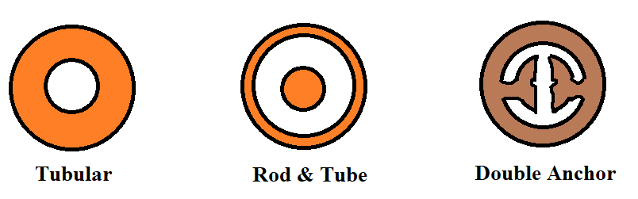

1. Name two popular types of igniters used in solid rockets.
   1. Pyrotechnic & Pyrogen